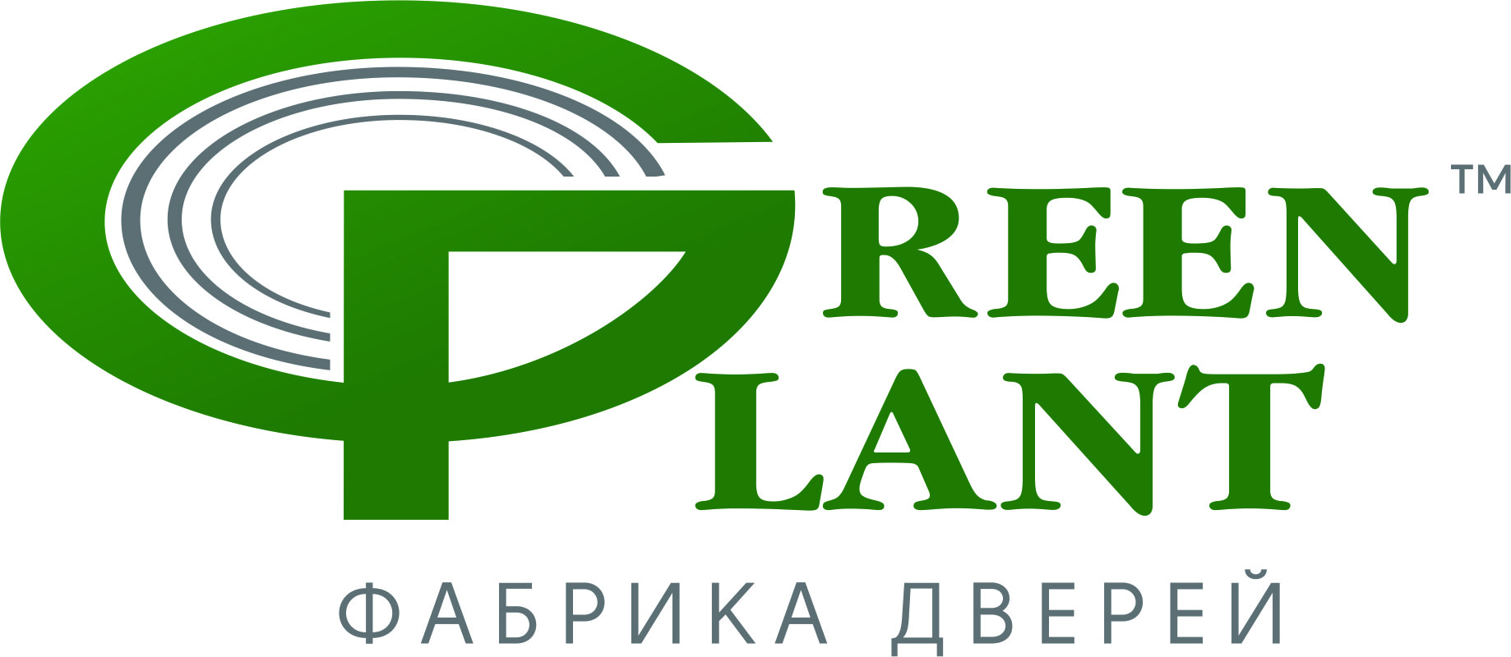
Commercial Proposal
Unitary Enterprise "Green Plant"

The “Green Plant” factory (Green plant™) produces connecting veneerdoors and is looking to cooperate with the wholesalers, wholesale and retail companies specializing in the sale of connecting doors.
The factory has been carrying out activities since 1998. We have a long-term successful experience on the markets of such countries as Russia, Kazakhstan, Uzbekistan, Turkmenistan, Kyrgyzstan, Azerbaijan, Ukraine, Moldova, Lithuania, Estonia, Latvia, Romania. High quality products and high volumes of output, unchallenged reputation put our factory in a row of the largest export enterprises of the Republic of Belarus.
The cyclical turnaround ensures the short term of production of wholesale orders (from 10 to 14 days) and enables to produce up to 15 000 door panels a month. The constant warehouse program for all range of goods is supported. Multistage control at all fabrication stages guarantees consistent high quality of products; dense packing of goods ensures safety on all transit to the Partner's warehouse.
The door frame is made of genuine pine tree. For finishing the door unit we use the only natural veneer of oak-tree, ash-tree and European nut-tree.
The rich facture of natural wood is accentuated with manual finishing. Due to patination, creation of Decapé effect, hand painting, dimensional decorative elements on cock beads and door trims, our doors gain a unique appearance at low selling prices.
The products are manufactured according to the Commodity Classifier For Foreign Economic Activity of the Customs Union:
4418 20 5000 –doors
4421 90 980 0–door trim
4421 90 980 0 –cock bead made of conifer
4421 90 910 0–cock bead made of MDF
4421 90 980 0 –door frames
4421 90 910 0–slamming strips
4412 99 300 2 –spacer bar

The products can be delivered by road and in railway containers. Shipment conditions are FCA, CPT. Our company covers all expenses of customs registration. Product samples are provided at no cost.
The individual approach to each Partner ensures favorable terms of collaboration.
For more information see the official site at www.Greenplant.by or in the price-list enclosed (Annex 1).
You can make a virtual tour at
http://greenplant.by/vystavka-flesh/index.html

We are looking forward to establish mutually beneficial partnership!

Unitary Enterprise "Green Plant"
The Republic of Belarus, 220007, Minsk, ul. Byhovskaya, 35-74

Reception, multi-line tel./fax:
(+375-17) 219-01-32
(+375-17)219-01-80

Sales Department:
(+375-29) 655-77-44
e-mail: greenplant@mail.ru
greenplant@tut.by

www.Greenplant.by

